CREATE VPC
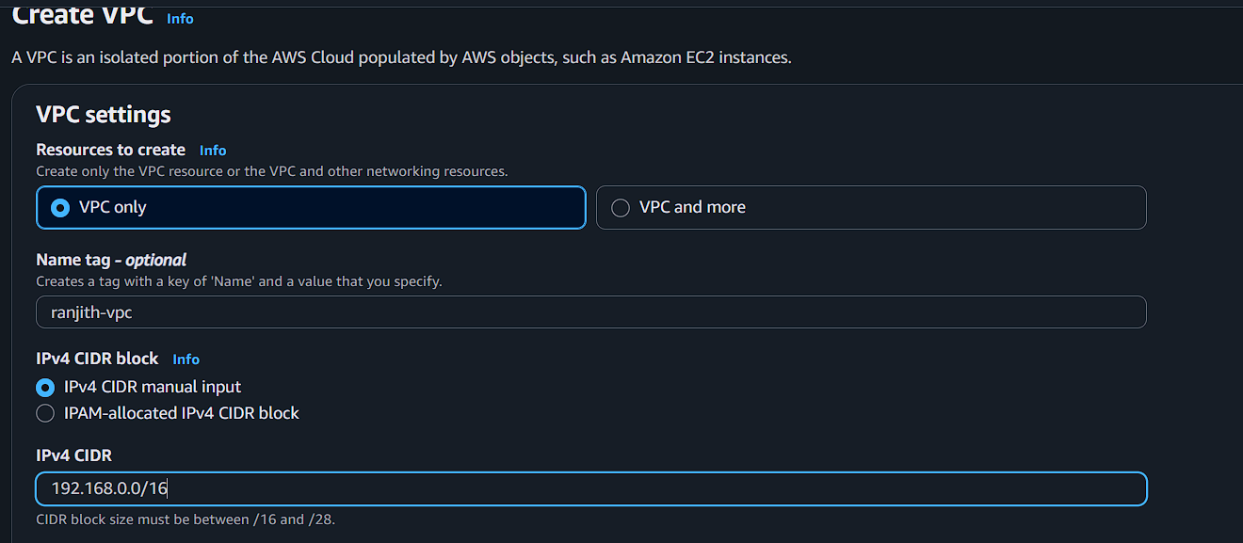
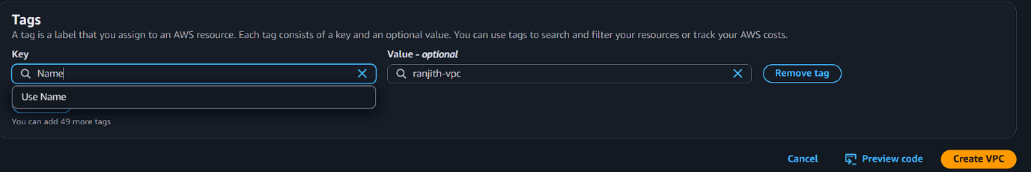
CREATE SUBNET
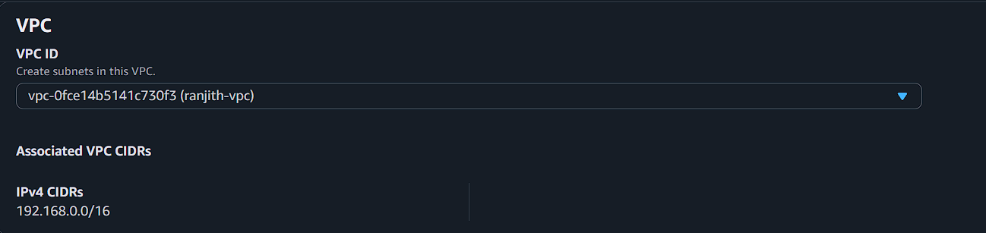
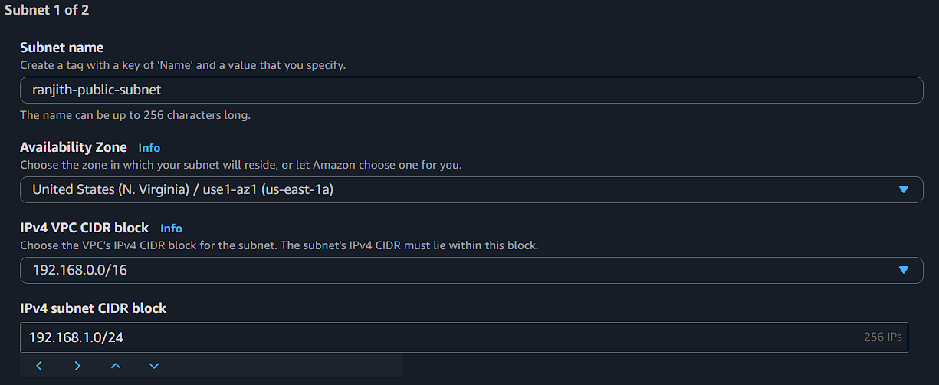
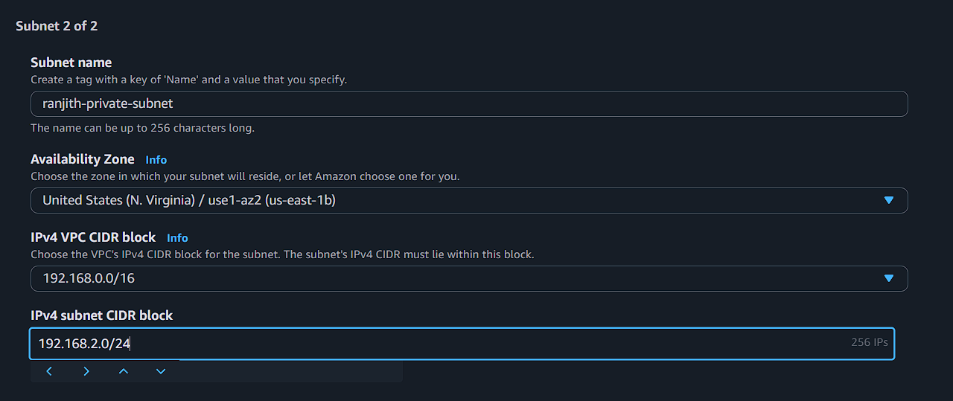

CREATE INTERNET GATEWAY
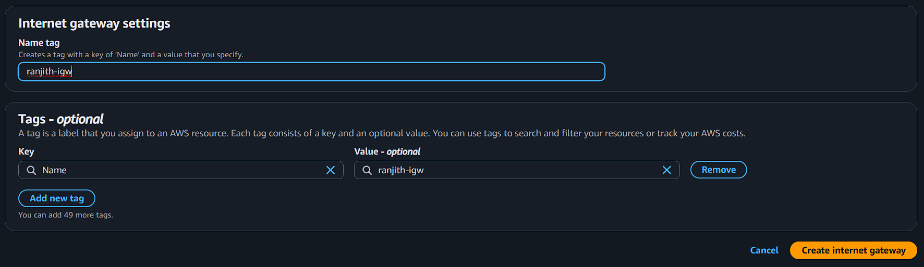
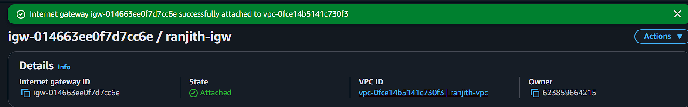

CREATE ROUTE TABLE
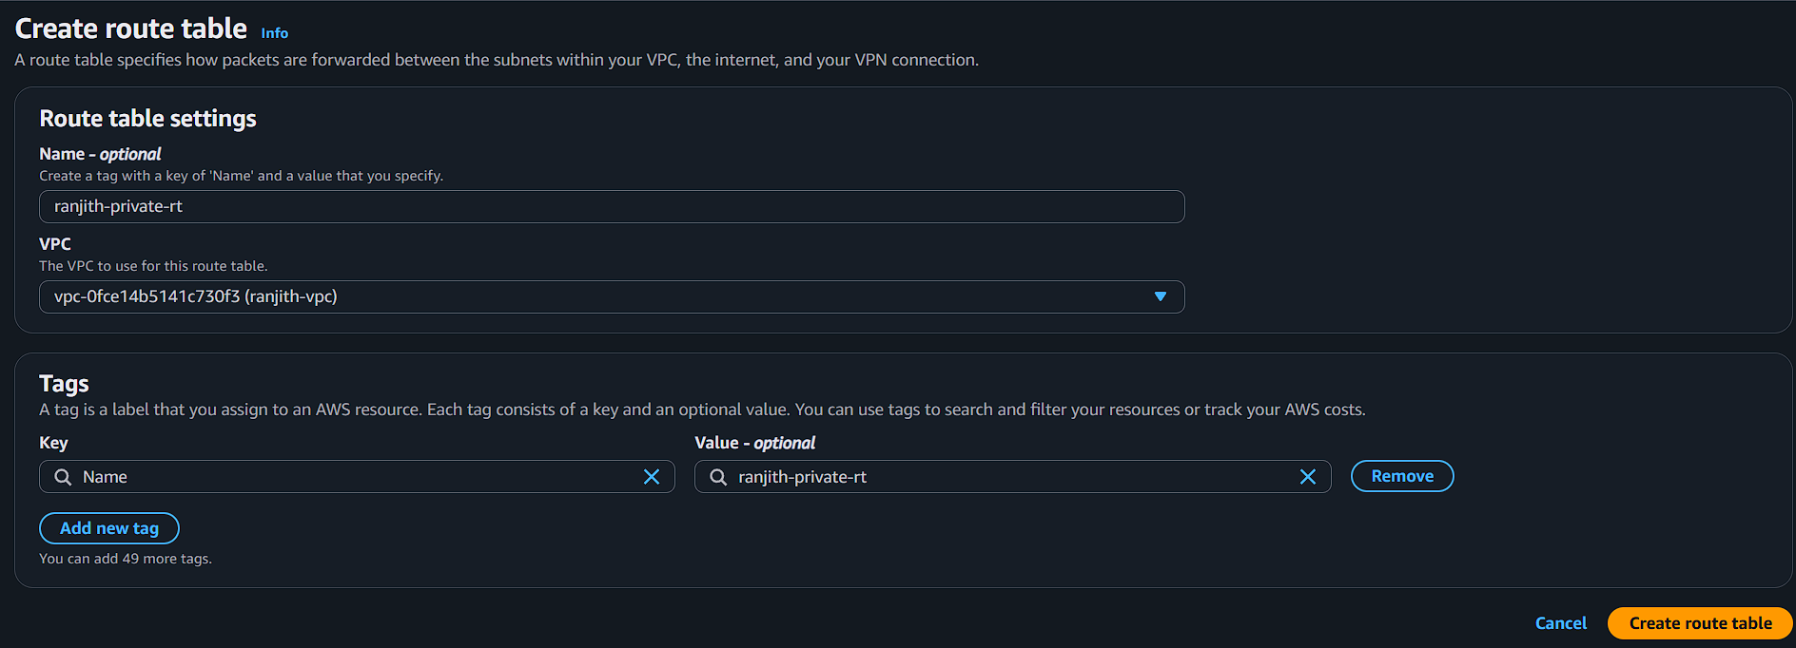
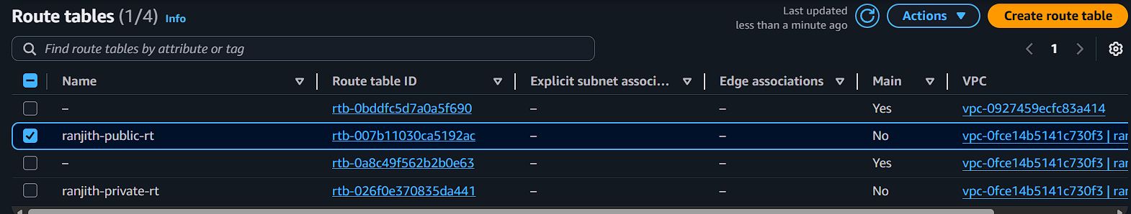

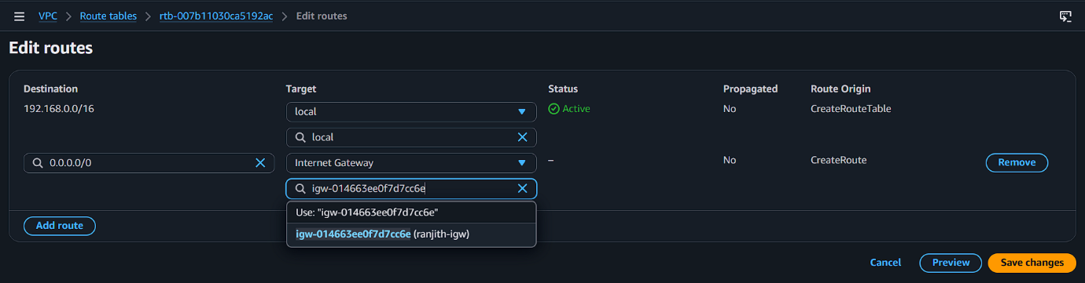
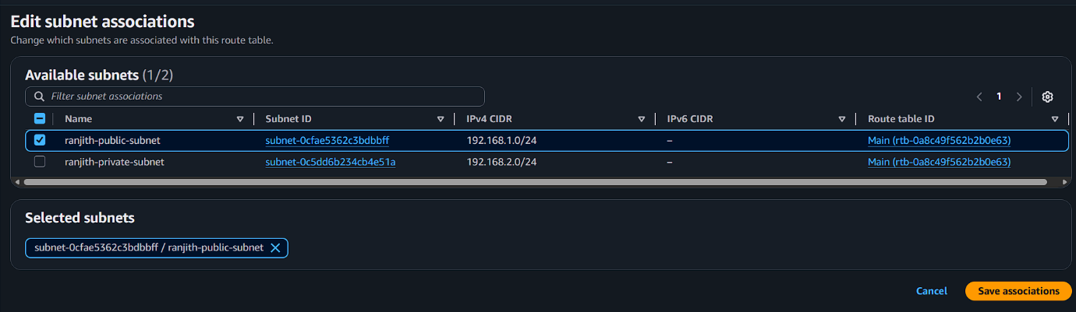
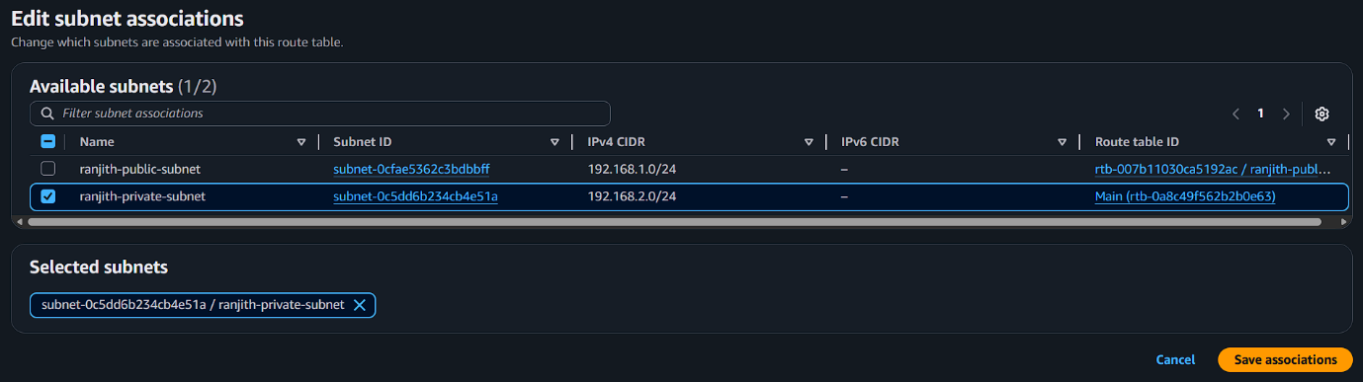

CREATE SECURITY GROUPS
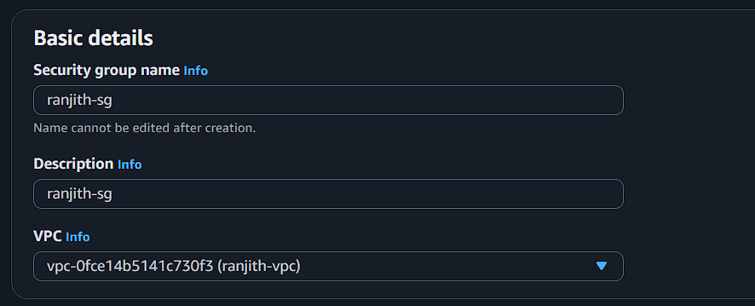

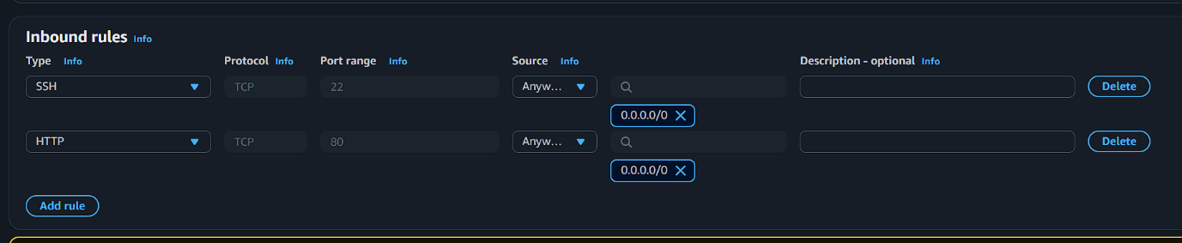

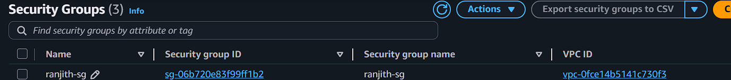

LAUNCH EC2 INSTANCE

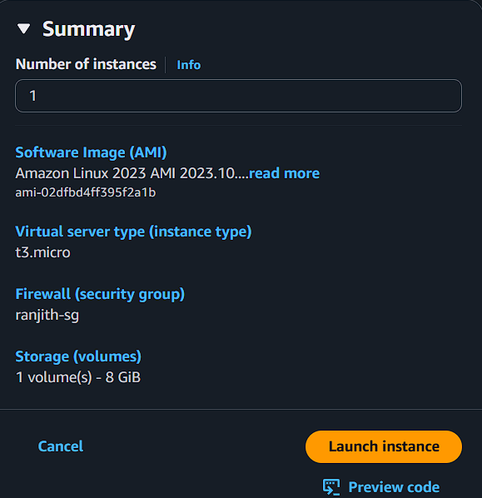

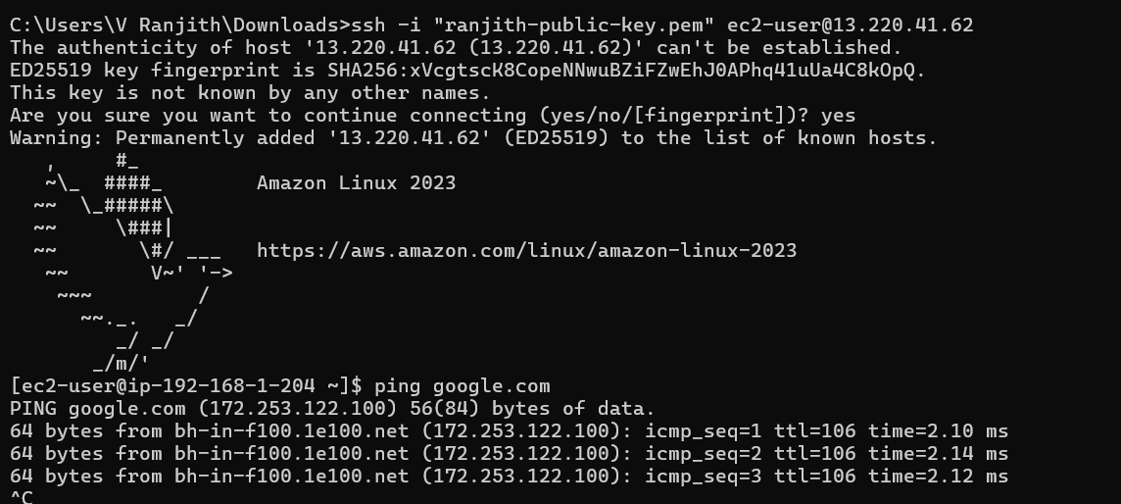

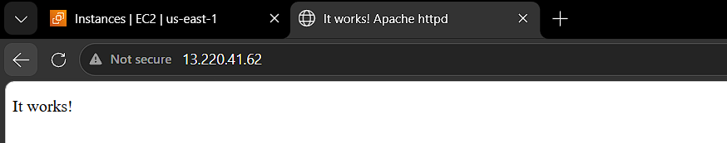

CREATE Network ACL
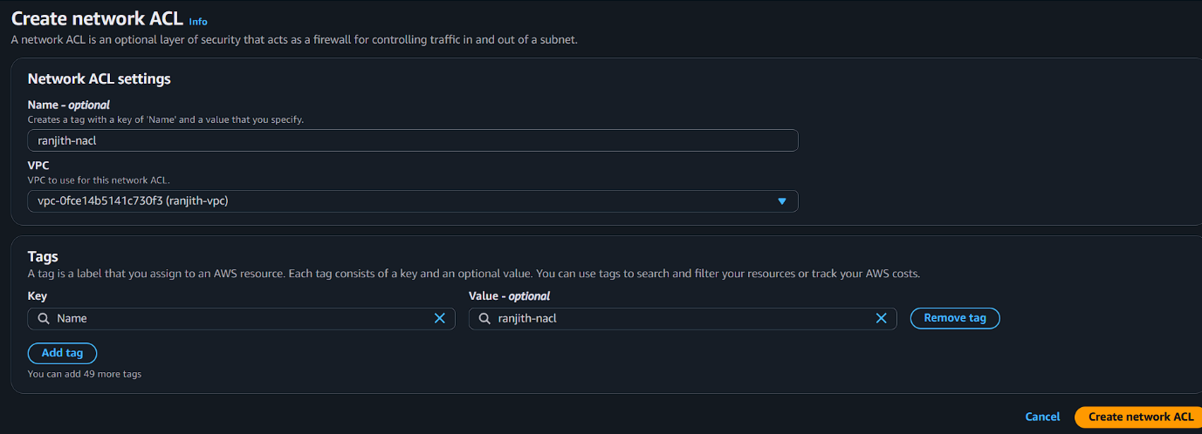

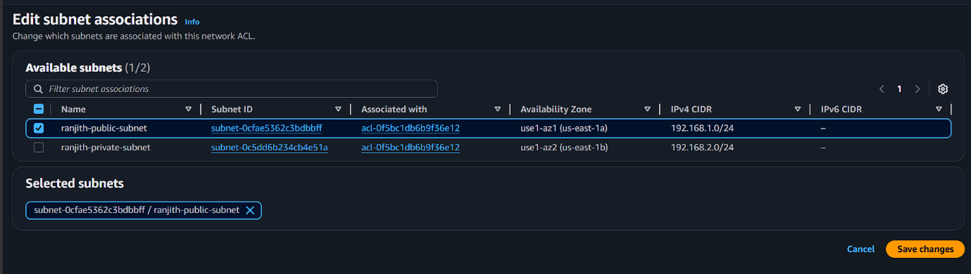

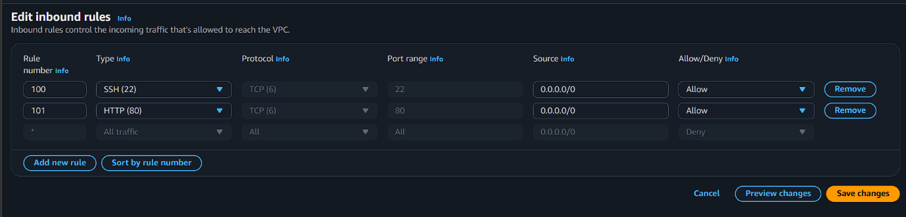

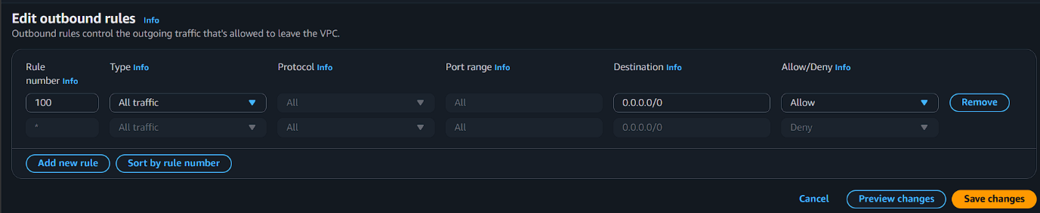

CHECKING PROCESS

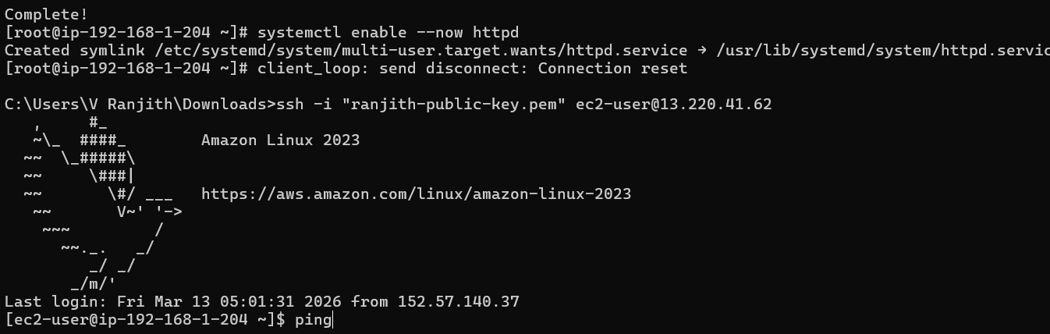



CHANGE THE NACL INBOUND RULES

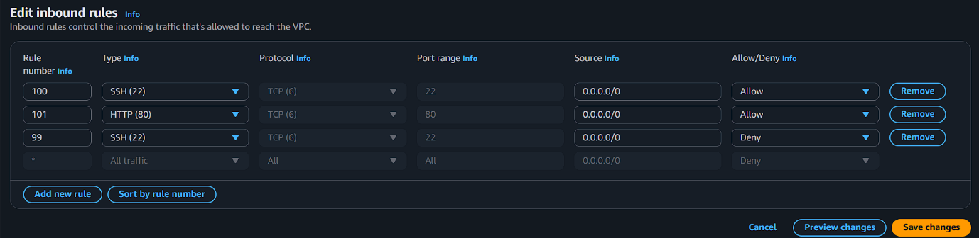

CHECKING PROCESS

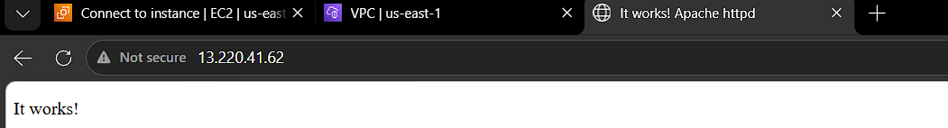

CHANGE THE NACL INBOUND RULES

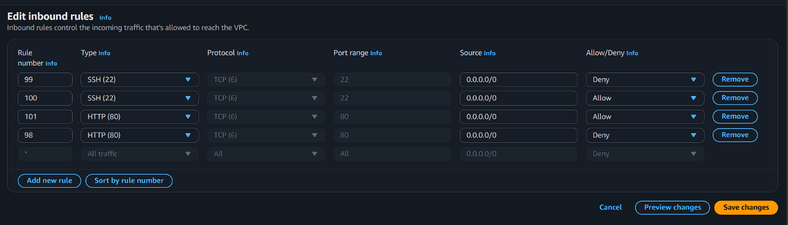

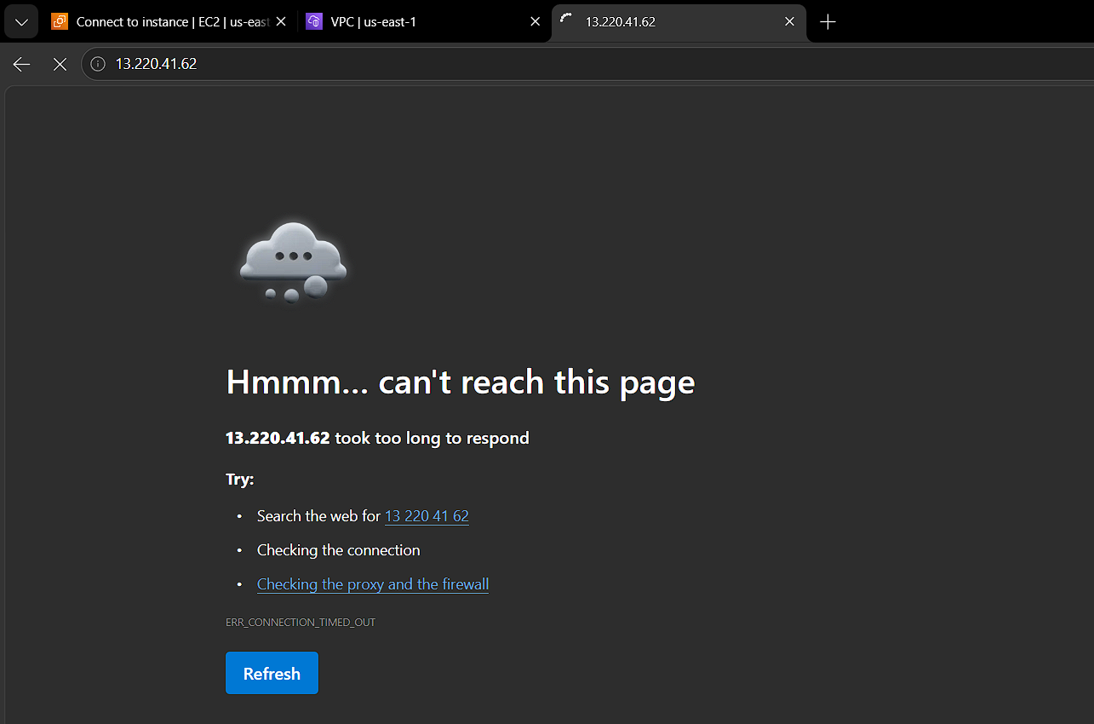

CHANGE THE NACL OUTBOUND RULES

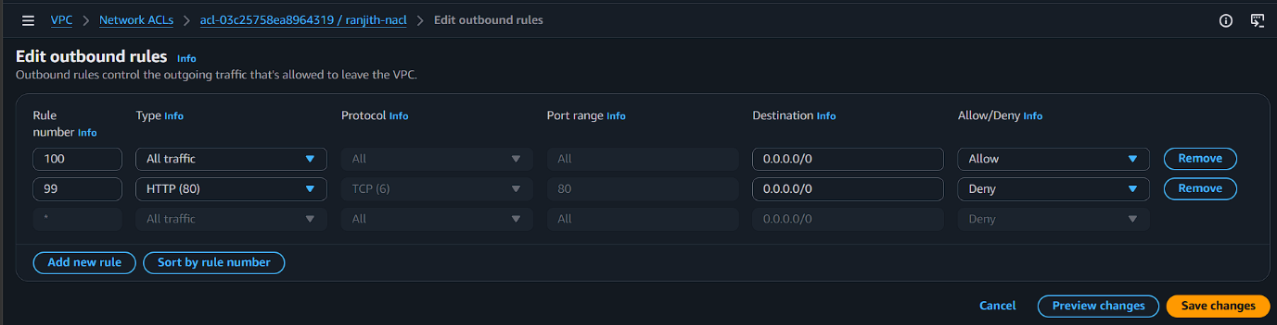

SSH into EC2 and test:
curl google.com
Result:
Connection blocked

